Regulations:
A14

H.T No

Sreenidhi Institute of Science and Technology
(An Autonomous Institution)
Code No: 4C303 Date: 23-Dec-2019 (FN)

B.Tech II-Year I-Semester External Examination, Dec-2019/Jan-2020 (Supplementary)
PROBABILITY THEORY AND STOCHASTIC PROCESS (ECE)

Time: 3 Hours Max.Marks:70

Note: a) No additional answer sheets will be provided.
b) All sub-parts of a question must be answered at one place only, otherwise it will not be valued.
c) Missing data can be assumed suitably.

Part - A Max.Marks:20

Answer all QUESTIONS.

1. | Define probability using the axiomatic approach. | [2M]
2. | Write any two properties of the Gaussian random variable. | [2M]
3. | State Central limit theorem. | [2M]
4. | Define continuous random process. | [2M]
5. | Define spectrum of a random process. | [2M]
6. | Define linear system of inputs. | [2M]
7. | Define conditional probability. | [2M]
8. | Define jointly Gaussian of two random variables. | [2M]
9. | Express the response of a linear system in terms of its impulse response 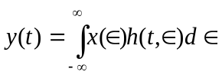 | [2M]
10. | Define characteristic function of a random variable. | [2M]
Part – B Max.Marks:50
ANSWER ANY FIVE QUESTIONS. EACH QUESTION CARRIES 10 MARKS.

11. | a) | If 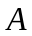 and 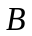are statistically independent events, prove that  (i) and 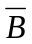 (ii) 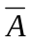 and are independent | [5M]
 | b) | A Speaks truth in 75% cases and B in 80% of the cases. In what percentage of cases are they likely to contradict each other in stating the same fact? | [5M]
12. | a) | A continuous random variable X has the density function. 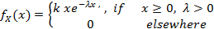 determine (i) k (ii) mean | [5M]
 | b) | A random variable 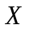 is known to have a distribution function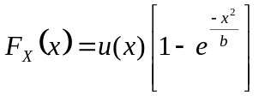,  where 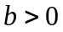 is a constant. Find its density function. | [5M]
13. | a) | Define joint density function and write its properties. | [5M]
 | b) | A joint probability density function is  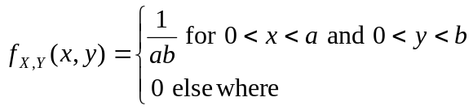  Find (i) 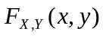 (ii) 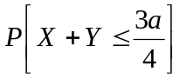 | [5M]
14. | a) | Given the autocorrelation function, for a stationary ergodic process with no periodic  components, is 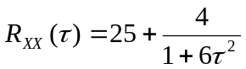. Determine the mean and variance of the process 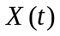 | [5M]
 | b) | Explain cross correlation of two random processes. | [5M]
15. | a) | Write the properties of cross power density spectrum. | [5M]
 | b) | Determine the cross correlation function corresponding to the cross power density spectrum given by 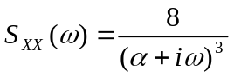 | [5M]
16. | a) | Explain the external noise sources of random noise. | [5M]
 | b) | If is a stationary random process with mean 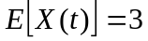 and auto correction function 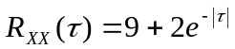, find (i) Mean value (ii) the variance of random variable 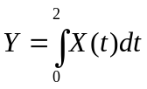 | [5M]
17. | a) | Assume that the height of clouds above the ground at some location is a Gaussian random variable  having 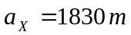 and 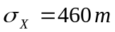, find the probability that clouds will be higher than 2750 m. | [5M]
 | b) | The joint probability density function of two random variables 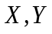 is given by  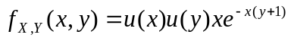. Determine 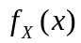 and 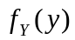 | [5M]
18. | a) | Determine the rms bandwidth of power density spectrum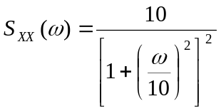 | [5M]
 | b) | Derive the relation between input PSD and output PSD of an LTI system. | [5M]

-- 00 -- 00 –

